

Q40/24

CONSULTANCY BRIEF
FOR THE PREPARATION OF DEVELOPMENT APPLICATION
FOR INDUSTRIAL SUBDIVISION
357 OXLEY HIGHWAY, GILGANDRA

Quotations close
11:00am on Friday, 24 January 2025

Issued 5 December 2024

Background
The Gilgandra local government area is situated in the central west of NSW and covers an area of 4800 square kilometers, including the township of Gilgandra and three smaller villages of Tooraweenah, Armatree and Curban.

Gilgandra Shire Council is intending to construct a new industrial subdivision at 357 Oxley Highway (Lot 12, DP 1296805), located at the western extent of Gilgandra across from the Shire Depot. A concept subdivision layout has been prepared by Council, comprising approximately 27 industrial lots. The site is located adjacent to the Oxley Highway and Aralee Road and is anticipated to progress industrial development in the area.

Objectives
The objective of this brief is to seek quotations from a suitably qualified and experienced consultant to prepare and provide all necessary documentation as outlined under item 1.3 to lodge a development application (DA) for the industrial subdivision at 357 Oxley Highway, Gilgandra (zoned E4 General Industrial, minimum lot size 5,000 m²).

Scope of Works
The preparation of the Development Application documentation is to be in accordance with the Environmental Planning & Assessment Regulation 2021 – Part 3 - Division 1 - Clause 24.
The scope of work includes performing and/or coordinating all necessary studies and assessments to support a DA for the industrial subdivision.
This includes, but is not limited to:
- Site plan showing existing and proposed lots, buffer zones, APZ and internal road network. Council will provide a concept site plan with proposed lots to aid this work.
- Statement of Environmental Effects. A biodiversity assessment relevant to this work is nearing completion which can be made available once finalised.
- Servicing Plan, including:
  - Water
  - Sewer
  - Stormwater
  - Telecommunications
  - Electricity Supply
- Road design
- Landscaping plan
- Bushfire assessment for the proposed subdivision in accordance with Planning for Bush Fire Protection (2019)
- Stormwater management plan
- Detailed traffic impact assessment addressing comments in TfNSW’s consultation (2024.08.30 - TfNSW Response - Planning Proposal - 361 Oxley Highway Gilgandra)
- Noise impact assessment

Council has undertaken studies, assessments and other work relevant to the preparation of the DA for the industrial subdivision as part of the recent rezoning process (Planning Proposal). These include:
- Detailed survey
- Preliminary traffic impact assessment (and TfNSW’s response through Planning Proposal process)
- Preliminary contamination assessment
- Strategic bushfire study
- Aboriginal cultural heritage assessment
- Water and sewer servicing strategy
- Geotechnical study
- Concept drawings with proposed lot layouts
- Preliminary electrical design
This information is available for the purposes of this work.
The successful consultant is expected to provide the final report with all necessary documentation to support Council’s DA lodgement. The lodgement itself will be done by Council’s Project team. The consultant shall respond to all enquiries relating to the Development Application from the approval authority. The scope of work is concluded once development consent is issued.

Site Visit
Council will make allowance for one site visit to traverse the site with the appointed consultant for familiarisation and to provide background information. Additional site visits should be itemised as a provisional pay item to be approved by Council prior to their undertaking. The consultant should make provision for all travel, equipment and administration necessary to perform the work in their fee proposal.

Study Area
The site of the proposed subdivision is Lot 12 DP1296805 (20.97 ha) across from the Gilgandra Shire Depot on Oxley Highway, immediately to the west of Aralee Road. A locality map is provided below.
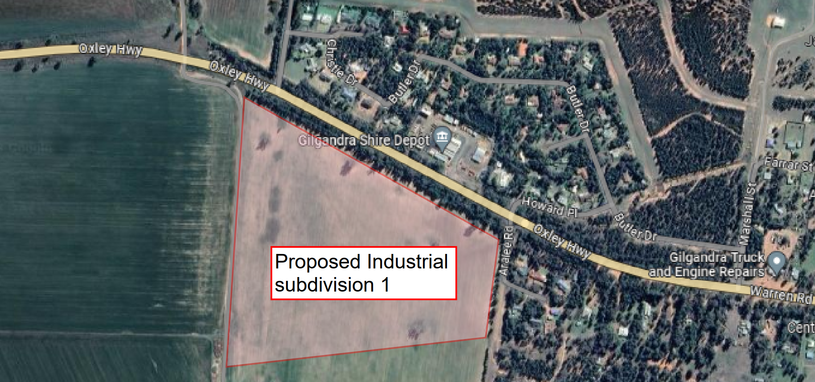

Deliverables
The final submission shall be delivered in electronic copies in both PDF and Word formats and in Dwg format where applicable. The draft report shall be submitted to Council allowing at least 10 days of review time. The final reports are due no later than 2 May 2025.

Invitation to Submit Fee Proposal
Council wishes to engage a consultant to prepare the DA documentation as soon as possible and as specified in this brief. The response to this brief should therefore indicate:

- when the consultant would be available to commence the project,
- the expected timing of preparation of each of the tasks within the scope.

Fee Proposals are to be submitted by 11am, 24 January 2025 via email to: council@gilgandra.nsw.gov.au marked Attention: Quotation Number 40/24.

Terms of Engagement
The consultant will be engaged in accordance with the terms and conditions set out in AS4122 – 2010 General Conditions for Consultants for a Lump Sum fixed price inclusive of all expenses and disbursements. The Lump Sum price shall not be subject to rise and fall.
Consultants should be aware that the final report(s) will be supplied to external parties for the purpose of obtaining permits and approvals, tendering and contracts.
The consultant must have current professional indemnity, public liability and workers compensation insurance for the duration of the work plus one (1) year. Copies of Certificates of Currency shall be submitted to Council prior to work commencing and upon request throughout the duration of the work.

Progress Claims
The Consultant shall be entitled to monthly progress payments until Development Consent is issued.

Clarifications and Further Information
All requests for clarifications or further information in relation to this scope of work must be in writing and directed to Council’s representative, Ashraful Mannan:
(email: amannan@gilgandra.nsw.gov.au).

No information or advice given by the above contact or representatives is to be relied upon unless it is in writing.
GILGANDRA SHIRE COUNCIL
STATEMENT OF BUSINESS ETHICS

GENERAL PRINCIPLES

Gilgandra Shire Council expects all its representatives, staff and Councillors to behave ethically and to abide by a written Code of Conduct. Council also expects private industry and its representatives to maintain similar standards of ethical conduct in their dealings with Council.

There are two main principles that form the basis of Gilgandra Shire Council’s business agreements. Firstly, there is the need to get the best possible value for public money. Secondly, Council needs to demonstrate impartiality and fairness at all stages of the process.

These principles enable suppliers to promote their interests productively and avoid potentially questionable activity. Those providing goods and services also benefit from the assurance that their competitors are required to behave in accordance with the same guidelines.

VALUE FOR MONEY is determined by considering all the factors which are relevant to a particular process. For example, quality, reliability, timeliness, service, initial and ongoing costs are all factors which can make a significant impact on benefits and costs. Value for money does not mean “lowest price”.

However, the lowest price bid might offer best value if it meets other essentials such as quality and reliability.

IMPARTIALITY AND FAIRNESS are about being objective, even-handed and reasonable. An impartial person will try objectively to establish criteria for determining best value for money and will work hard to objectively assess each quotation against criteria. A fair person would not for example change or introduce new selection criteria midway through the quotation process without advising all persons submitting a quotation.

Being impartial includes taking into account the practicalities of a given situation. Impartiality does not require for example inviting bids from firms which have performed poorly in the past. In some circumstances, fairness takes into account the effects of actions of others. It would be unfair to call quotes when there is no serious intent to award a contract subject to a satisfactory offer.

Fairness does not necessarily mean pleasing everyone. Some people are occasionally adversely affected by fair decisions. Council operates from a view point where it wishes to be fair in all its dealings and minimise where possible, any adverse effects of its decisions.

Gilgandra Shire Council expects staff and Councillors to:

- Respect and follow Council’s policies and procedures.
- Treat all quotes for the supply of goods and services equitably.
- Promote fair and open competition while seeking best value for money.
- Protect confidential information.
- Meet or exceed public interest and accountability standards.
- Respond promptly to reasonable requests for advice and information.
- Avoid situations where private interest could conflict with public duty.
- Never solicit or accept remuneration, gifts or other benefits from a supplier for the discharge of official duties.

Council expects Contractors, suppliers and consultants to:

- Respect the conditions set out in documents supplied by Council,
- Respect the obligation of Council staff to abide by Council’s procurement and disposal policy.
- Abstain from collusive practices.
- Prevent unauthorised release of privileged information, including confidential Council information.
- Refrain from offering Council employees or Councillors any financial or other inducement which may give any impression of unfair advantage.

HOW IT WORKS

There is no absolute definition of “ethical behaviour”. If there is any doubt about the ethics of a proposed action, a sensible test is whether or not you would be happy to see your behaviour published in the local newspaper.

Staff and Councillors of Gilgandra Shire Council or those in the employ of a Contractor, supplier or consultant who are concerned that a breach of the law or of ethical conduct may have taken place, should discuss the matter with Gilgandra Shire Council’s Public Officer on (02) 6817 8800.

If an apparent breach of any agreed standard of ethical conduct is identified, then the matter should be immediately brought to the attention of the General Manager or the Public Officer on (02) 6817 8800.

CODE OF CONDUCT

Council Contractors will also be required to observe the relevant provisions of Council’s Code of Conduct based on the Department of Local government Model Code of Conduct for Local Councils in NSW.
https://www.gilgandra.nsw.gov.au/files/assets/public/your-council/access-to-information/code-of-conduct-adopted-16-april-2019.pdf

