

STATEMENT OF ENVIRONMENTAL EFFECTS

PROPERTY DETAILS

LOT 232 and 233 DP6192
68 Myrtle Street, Gilgandra NSW 2827

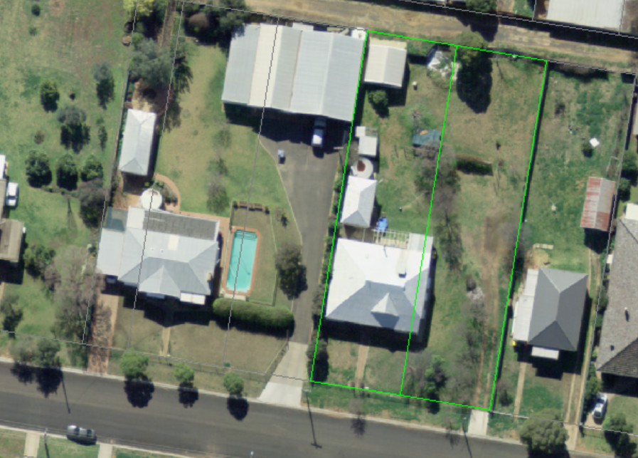

DESCRIPTION OF THE SITE & LOCALITY

The site is located in the residential area of Gilgandra in the R1 Residential Zone. The development involves demolition of all structures on the lots in readiness for the lodgement of a future development application for approximately 5 x 2 bedroom villas as part of Council’s Aged Care Workers Housing Accommodation Project to construct and make available more residential housing for essential workers required in the aged care services delivered by Council. The structures on the site include a dilapidated disused weather board house, a disused studio, and a steel framed shed. The site has occupied adjoining residential dwellings and a rear lane access.

DETAILS OF THE PROPOSED DEVELOPMENT

This development involves the demolition of structures by a licensed contractor in accordance with AS2601-2001. The licenced contractor will be appointed following receipt of the DA consent and a Request for Quotation Process. A demolition management plan has not been prepared; however it is envisaged that the successful contractor will submit one for approval prior to any works commencing. Council has reached an in principal agreement to purchase the property and the sale is pending contract settlement.
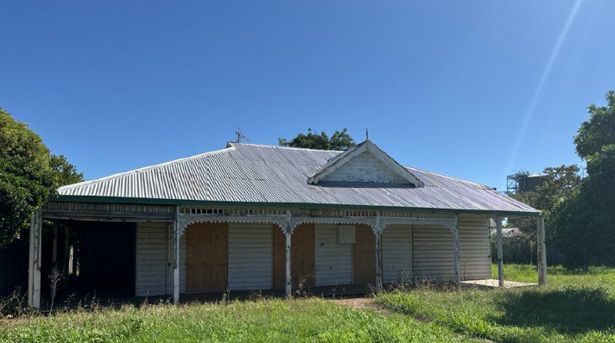

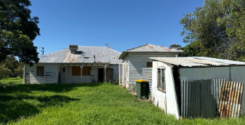

OWNER(S)

Name: Nicholas Carroll and Stefanie Allen as directors of Little Karinya Pty Ltd (Owners Consent Attached)
118/80 McIntyre Street, HENDRA, QLD 4011

APPLICANT DETAILS

Name: Jason Brook
Gilgandra Shire Council

Address: 15 Warren Road, Gilgandra NSW

MATTERS FOR CONSIDERATION YES / NO

(Matters for consideration pursuant to Section 79C of the Environmental Planning and Assessment Act 1979)

(a) Compliance with relevant environmental planning instruments
(i.e. Local Environmental Plans, draft LEPs, Development Control
Plans).
YES NO
(i) Is the land zoned residential? ×

(ii) Is the proposal permissible within the zone? ×

The proposed development is consistent with the R1 Residential zoning and the associated objectives and is permissible with consent.

This development will be the precursor to a subsequent medium density development application

(iii) Is there a Development Control Plan (DCP) that
applies to the land or the proposed development?
(Refer to Table on last page for Council’s DCP’s and their applicable zoning)
×

(iv) If yes, specify.

Gilgandra Shire Development Control Plan:

Adaptive reuse opportunities will be encouraged to repurpose the existing steel shed located at the rear of the lot. No other buildings are salvageable, however elements within the current buildings such as federation style mouldings and French doors will be repurposed by the current owners.

All materials moved offsite is transported in accordance with the requirements of the Protection of the Environment Operations Act 1997 to minimise impacts.

As part of the demolition plan to be submitted by the contractor, a requirement will be to retain all records demonstrating lawful disposal of waste and keep them readily accessible for inspection by regulatory authorities.

It is imperative to reduce the impacts to the Gilgandra Waste Facility that effective waste minimise is applied and the correct process implemented for handling the hazardous substance identified e.g. Asbestos.

(v) Does the proposal comply with any relevant DCPs? ×

(vi) If no, specify;

(Note If unsure check with Council’s Environmental Services Division or obtain a S149 Zoning Certificate from Council)

(b) Likely impacts of the development, including environmental impacts on both the natural and built environments of the locality.
YES NO
(i) Will the proposal result in the loss of any vegetation
from the site? ×

(ii) If yes, outline details and identify on site plan.

During the demolition process, it is expected that excavators or other trucks and machinery will be used. The works will need to be controlled to mitigate the dust and noise impacts to adjoining neighbours. These will be matters for the contractor however will include but not limited to: restrictions on operating hours to comply with Council standard construction timeframes; minimising traffic movements and following a set path of travel; Removing Hazardous materials in accordance with the Hazmat Materials Register & Management Plan (50143) (see attached); and
Implementing effective dust surpass techniques in accordance with the AS 2601- The Demolition of Structures.

(iii) Are any landscaping works proposed on the land? ×

YES NO
(v) Does the proposal involve excavation or filling of the site?
×

(vi) If yes, outline details and/or identify on plans.

(vii) Is vehicular access available from the street? ×

(viii) Outline details of vehicular access and parking arrangements (i.e. location, carparking, etc)

Access will be via Myrtle Street

(ix) Outline where possible building works are proposed to be sited on the land to demonstrate the relationship to existing building (i.e. distances from the boundaries, etc). These details should be shown on the site plan.

No changes, the existing building footprint will be demolished.

(x) What measures will be undertaken to ensure that the natural flow of the water is not redirected (e.g. pipes under driveways etc?

No changes to the existing stormwater management arrangements planned. This will be a consideration of the future development

(xi) a) How will the proposal impact on neighbouring properties?

There will be short term impacts to adjoining neighbours as a result of the demolition activities however through the demolition plan of management and prescribed conditions of consent by Council these impacts will be minimised.

b) What measures will be proposed to reduce the impact of noise, dust, odour, vehicle movements etc. on neighbours?

Yes, noise is expected to be generated from machinery and truck movements. There is potential of noise impacts during demolition but these are considered minimal and can be controlled through conditions controlling hours of operation. In this regard, it is proposed that no works will occur before 7am or after 6pm weekdays, before 8am or after 1pm on Saturdays and no work on Sundays.

Dust is likely if uncontrolled measures are applied however, it will be the contractors responsibility to control dust through water suppression and other means as proposed in the demolition management plan to be submitted by the contractor as part of the Request for Quotation (RFQ) Process. It is envisaged that such demolition plan will be assessed and deemed satisfactory before the contractor is appointed.

Hazardous Substance report has been completed and included within the application and outlines an action plan which will be complied with in its entirety. Nothing within this report is unexpected for a building of this age.

The house is an older federation style, but is in such poor condition that the costs of upgrades have been prohibitive to the current owners. The property is not heritage listed.

(c) Suitability of the site for the development.
YES NO
(i) Is the area an established residential area? ×

(ii) Are existing utility services available and adequate to
serve the development (i.e. electricity, water, sewerage, telephone, gas, stormwater and garbage)? ×

(iii) If no, what alternative arrangements are proposed?

(iv) Are there any other matters relating to your proposed
development or use, such as management details,
operating or construction hours, noise, etc? ×

If yes, please specify.

Any Trees or vegetation proposed from the site will be disposed via the green waste streams at the Waste Facility

It is expected that the successful contractor will implement waste minimisation practices to reuse and recycle demolition materials where possible

(v) Have there been any soil contaminating activities (e.g. sheep dips, fuel storage, asbestos etc) on the land previously? If yes, explain what. ×

The submitted Hazmat Materials Register & Management Plan (50143) (see attached) outlines the hazardous substances identified. It is not unexpected that a property of this age will contain bonded asbestos however this will be removed by a licence contractor and disposed of at the waste facility in accordance with the appropriate asbestos disposal guidelines. No friable asbestos or other hazardous material have been identified.

(vi) Provide a statement on vehicular access, driveway design and location. Will any upgrades need to be made to existing? If so explain.

As discussed earlier, access via Myrtle Street, however if the need arises, a secondary access to the site is possible via the rear lane but this is unlikely.

(vi) What measures will be undertaken to mitigate any vehicular impacts to neighbours both in the short term and the long term.

Ensuring compliance with approved hours of operation and defining a set path of travel to and from the waste facility

(viii) Provide a statement on how the proposed development fits in with the character of the locality

N/A

